**Email Spam Classifier**

**Overview**

This project aims to classify emails as either 'Spam' or 'Ham' using machine learning. By doing so, it helps in segregating unwanted or potentially harmful emails from the ones that are important, improving the user's email management experience.

**Technologies Used**

* Python 3.x
* Pandas
* Scikit-learn
* NumPy

**Data Set**

The dataset contains 5572 records with two features: 'Category' and 'Message'. 'Category' has two classes - 'spam' and 'ham', and 'Message' contains the text of the email.

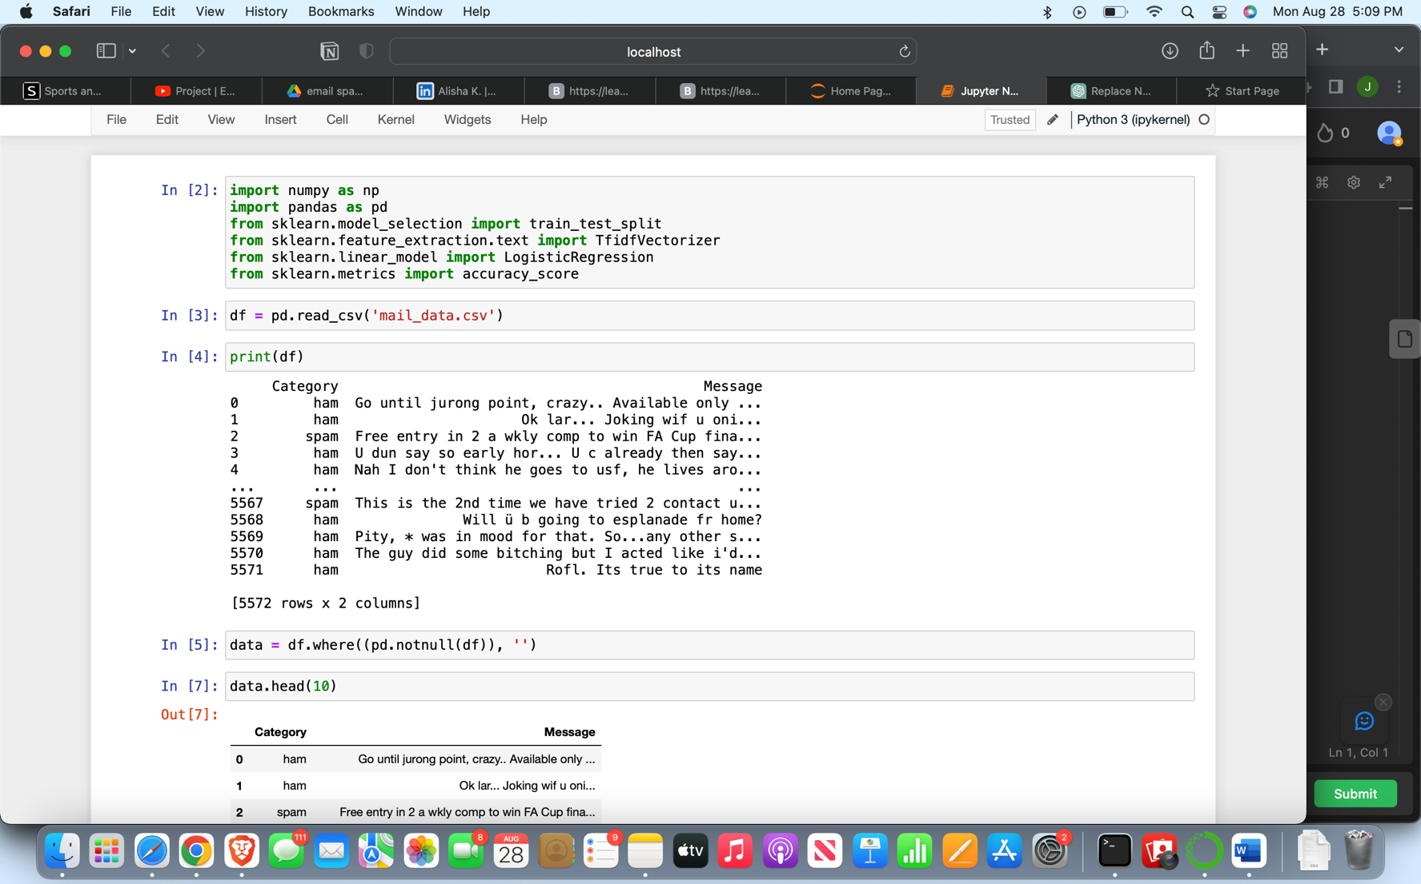

**Methodology**

**Data Preprocessing**

* Loaded the dataset using Pandas.
* Handled null values by replacing them with empty strings.

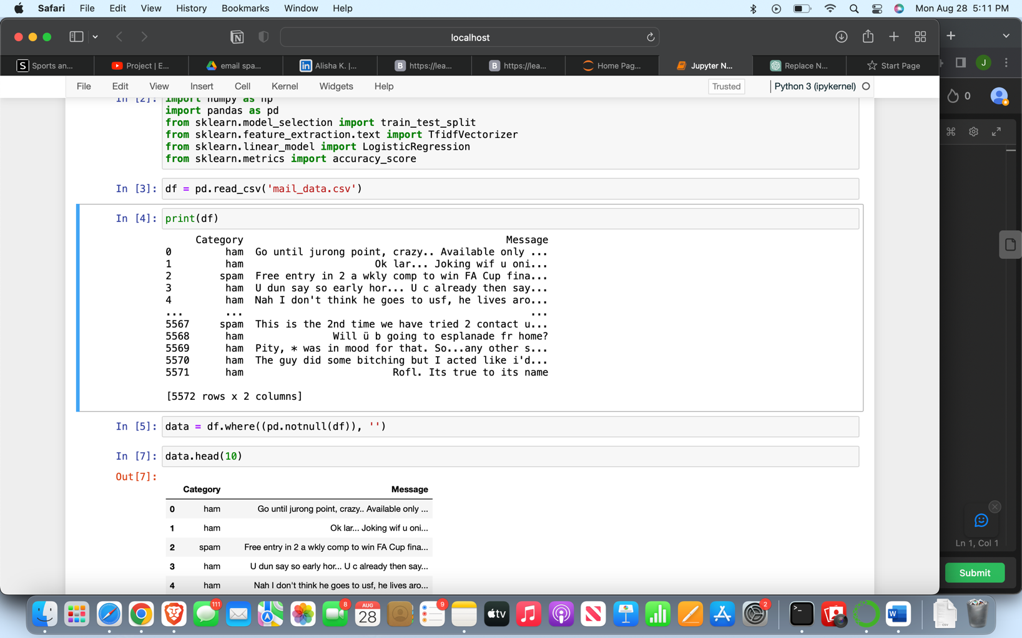

**Feature Engineering**

* Converted the 'Category' to numerical values: 'spam' as 0 and 'ham' as 1.

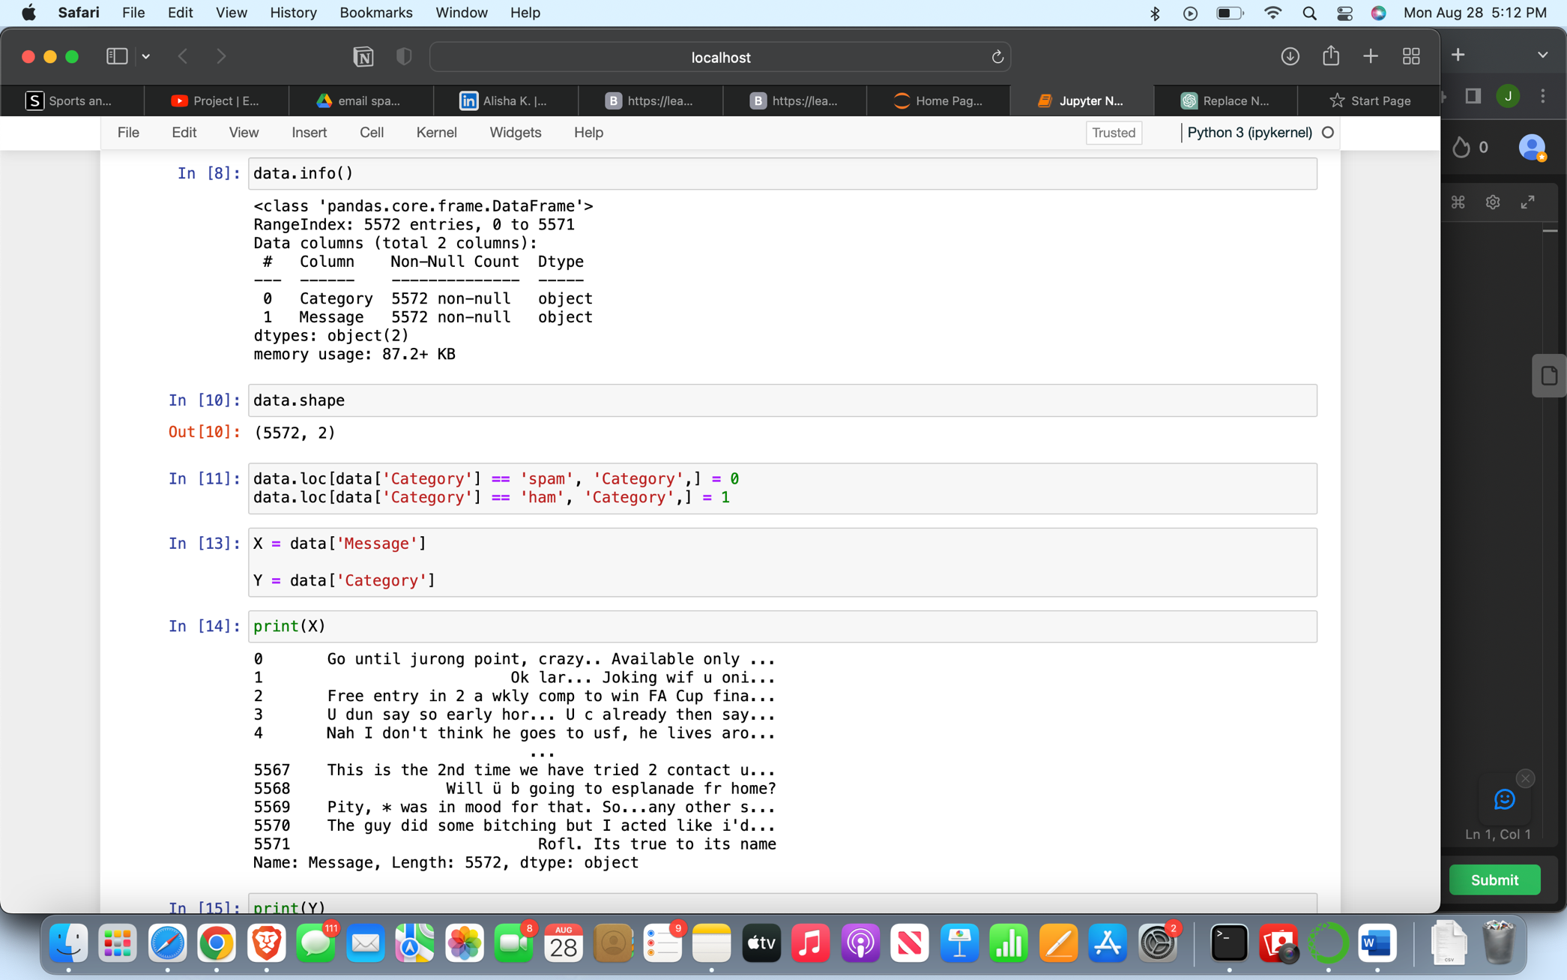

**Train-Test Split**

Used 80% of the data for training and the remaining 20% for testing.

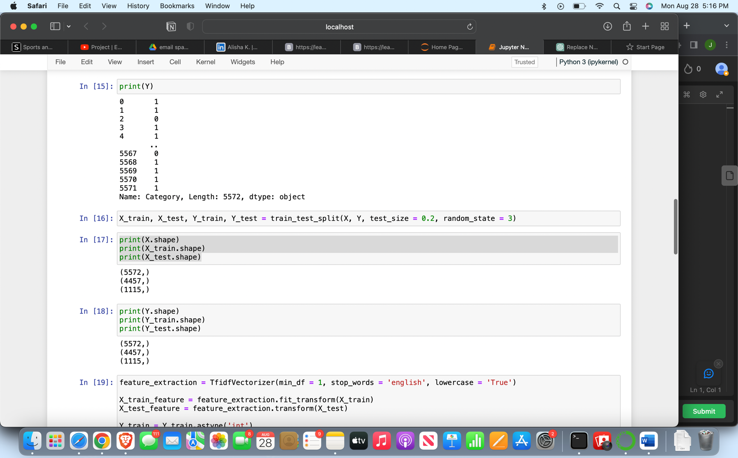

**Text Vectorization**

Used TF-IDF Vectorization to convert text data into numerical form.

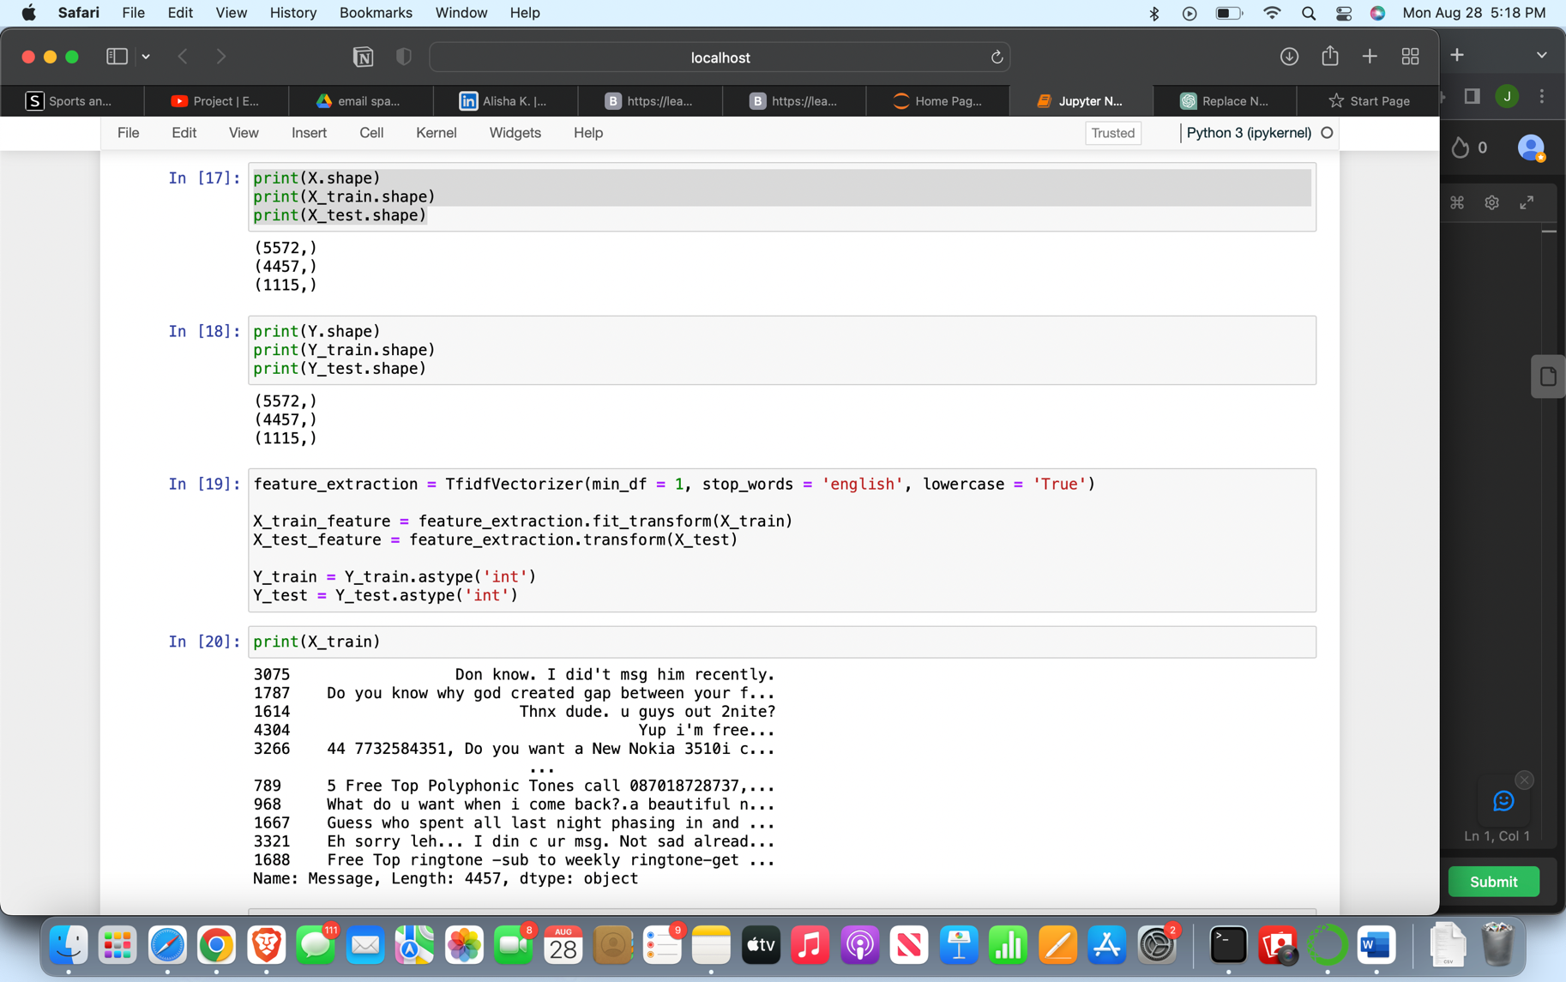

**Model Training**

Trained the model using Logistic Regression.

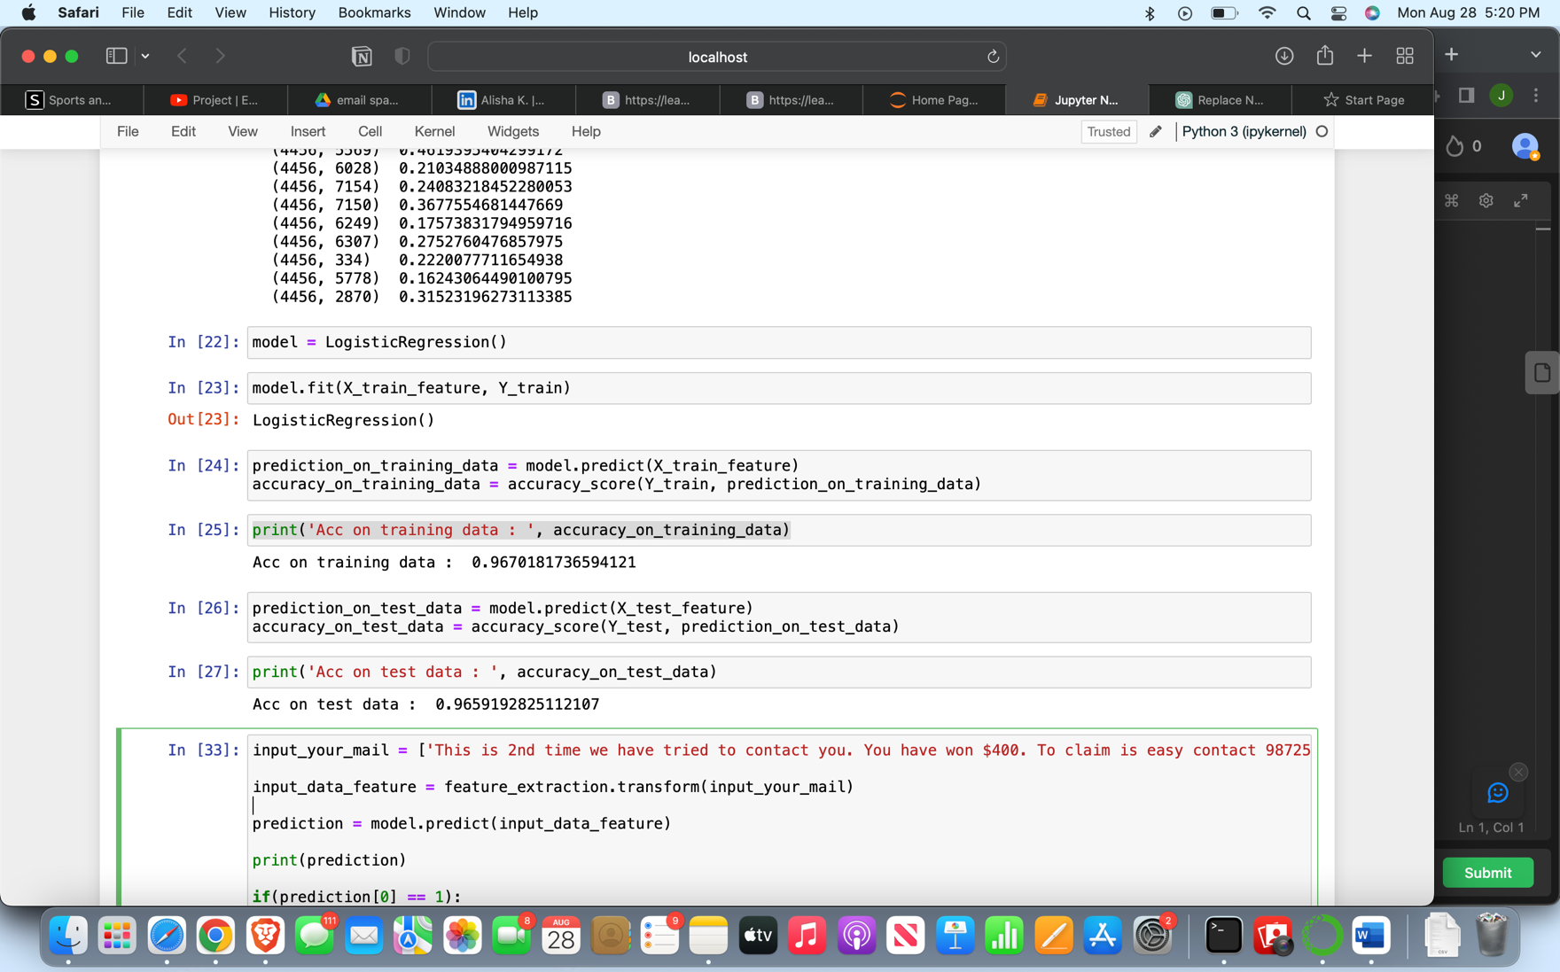

**Evaluation**

* Achieved an accuracy of approximately 96.7% on the training data.
* Achieved an accuracy of approximately 96.6% on the test data.

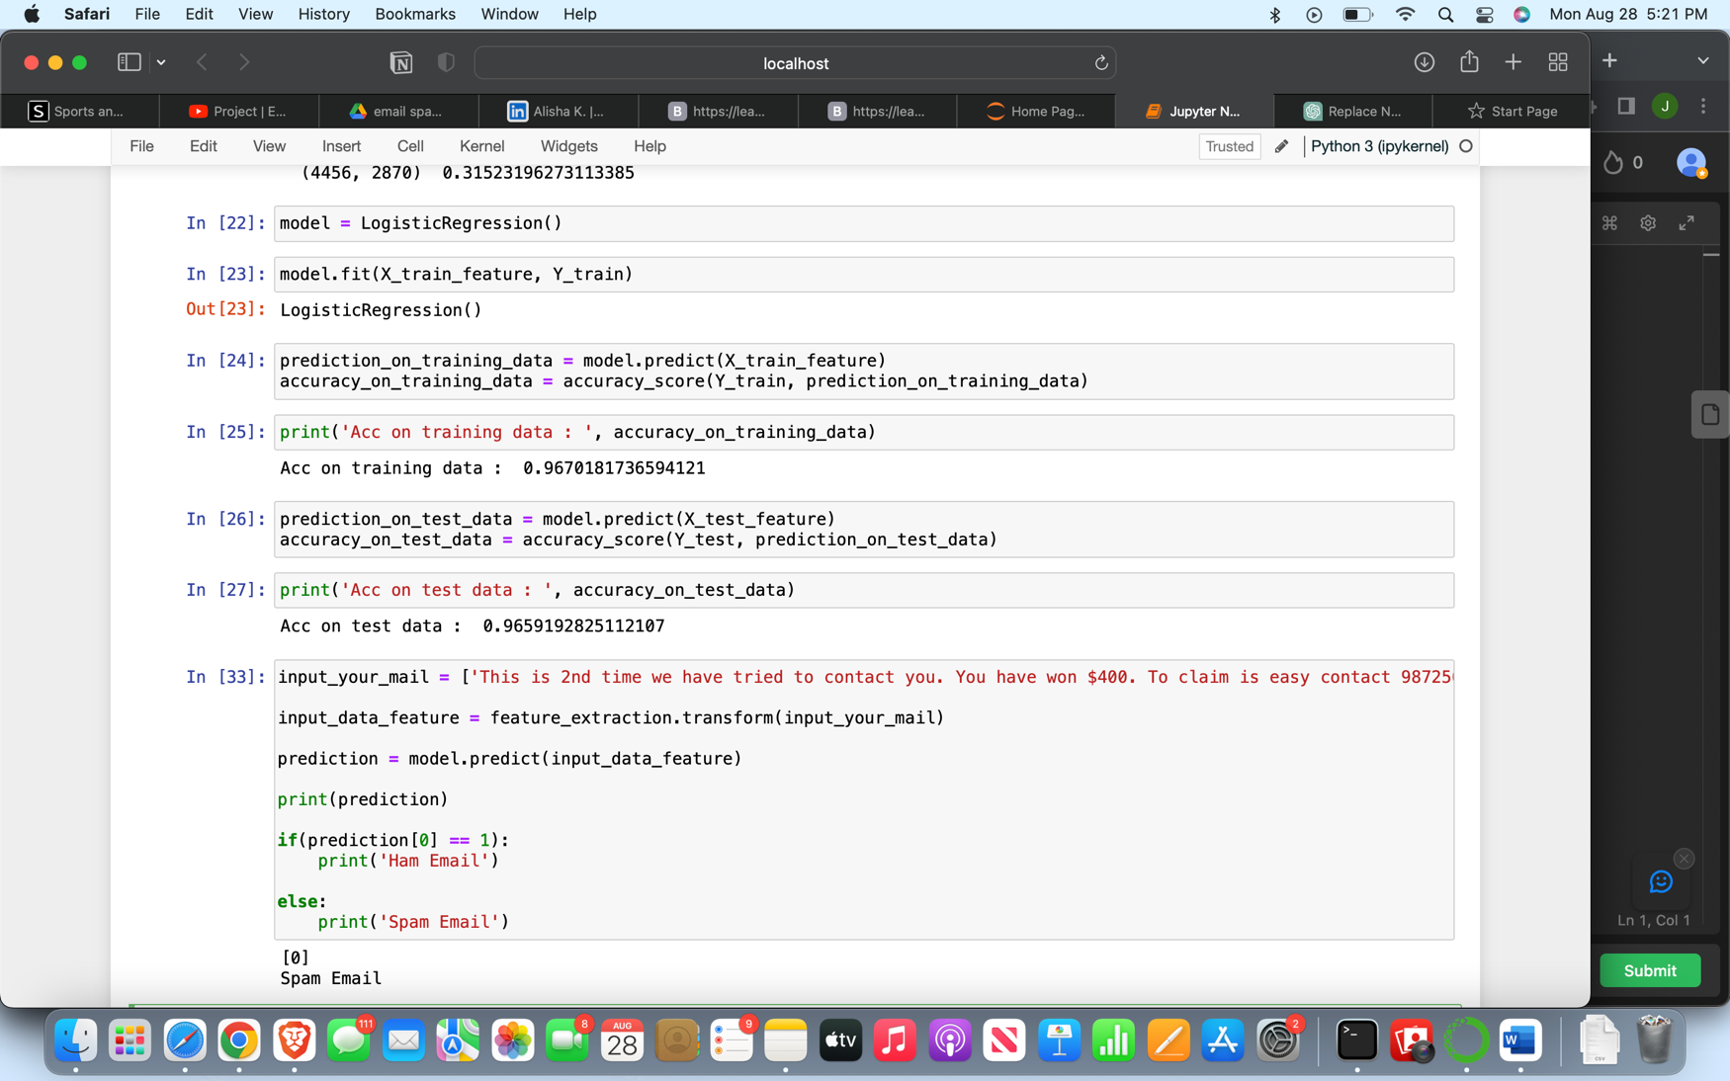

**User Input**

The model can take an email as input and classify it as either 'spam' or 'ham'.

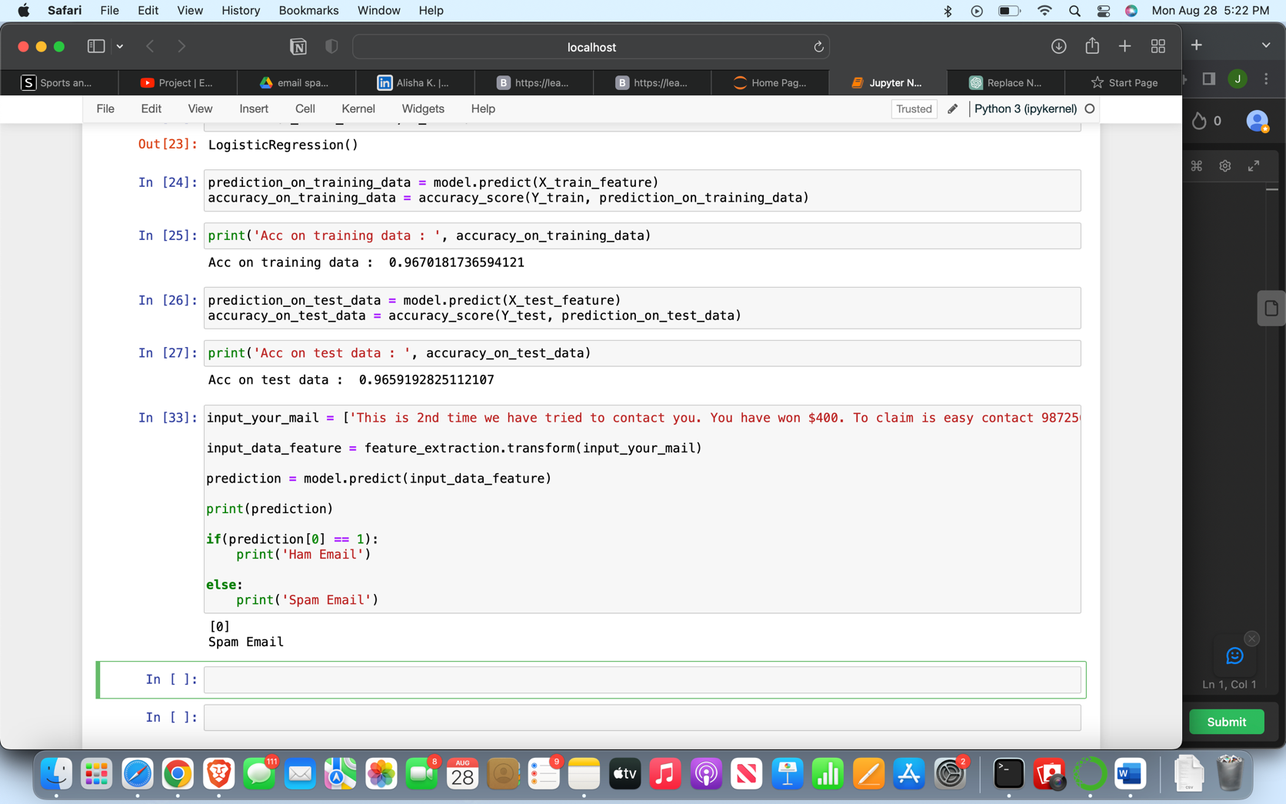

**Future Scope**

* Implementation of different algorithms to improve the accuracy.
* Addition of more features to refine the classification.